# A2 READING SAMPLE TEST

## Task 1. Choose the best answer

1. Louisa May Alcott published her first book, a ……………… of fairy tales, in 1854.
   1. collect B. collection C. collective D. collectively
2. The development of synthetic fibers after 1940 led to the production of new types of fabrics …………. were more durable and easier to care for.
   1. that B. where C. who D. why
3. The discovery of the halftone process in photography in 1881 made it possible

………………. photographs in books and newspapers.

* 1. reproduce B. to reproduce C. reproducing D. reproduced

1. Nearly 450,000 businesses are started in Britain every year. One third ………… these stops trading during the first three years.
   1. from B. of C. among D. in
2. Many of the …………… characteristics that distinguish human beings from mother primates are related to the ability of people to stand upright and walk on two legs.
   1. physical B. mental C. emotional D. educational

## Task 2. Choose the best picture

1. 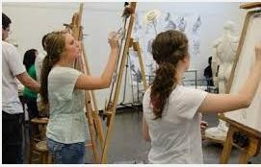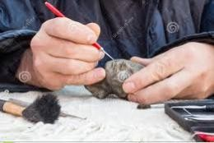Over 20,000 people so far have visited the national museum to see the collection of works by the popular Colombian artist Botero. That is the largest number of visitors the gallery has had for several years. This is the first time that Botero‘s work has been shown in this area, and the collection includes some of his best-known paintings and sculptures.

A B C

1. 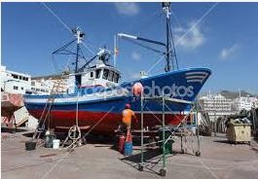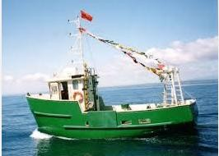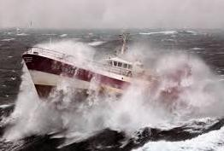Coast Guard boats are searching for a fishing boat with a crew of four, which has been missing for two days. Shortly after the boat left land, it ran into a very bad storm and sent out a message for help. The Coast Guard thinks that the boat probably sank during the storm.

A B C

1. 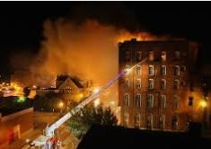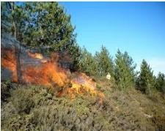We were staying in this hotel in Thailand when there was a fire. I was so scared when I heard the fire alarm go off! I got out of the hotel as quickly as I could. The hotel was badly damaged, and some people lost their clothes and money. In the end, though, we were lucky. No guests or staff members were injured.

A B C

1. 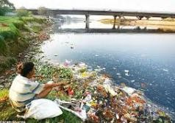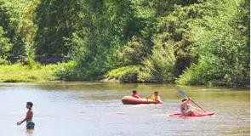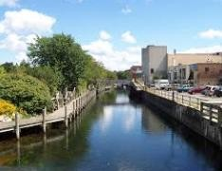I grew up around here, and the river has always been really polluted. Industries were dumping all sorts of chemicals and waste into the water, so the river really smelled bad. You wouldn‘t even think of swimming there. Well, I decided to do something about it. My neighbors and I wrote a letter to the mayor asking him to force these industries to clean up the river. I really hope the government listens to us.

A B C

1. 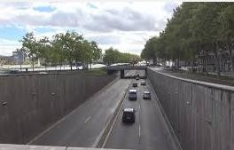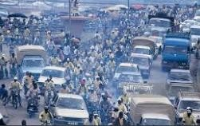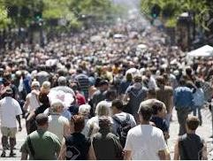It‘s almost impossible to get across the city in less than an hour and a half during rush hour. There are too many cars and vehicles on the roads. There are only two freeways, and they just can‘t handle the traffic. It is really stressed to go out at this time.

A B C

## Task 3. Answer the questions with NO MORE THAN FOUR WORDS Exercise 1

For a long time, people believed that there was a place in Himalayas where the inhabitants lived forever. They called the place Shangri-La. This name came to mean

―paradise‖ in the English language.

The people here don‘t live forever, but many live to be over one hundred years old. They appear to be among the healthiest people in the world. Why is this? People who have traveled to this remote area say it‘s because their diet is so healthy. The inhabitants eat only what they grow. Grain, fruit, and vegetables are their daily food. They seldom eat butter or eggs. They eat meat only on important feast days. Their only sweet dish is dried apricots. They never drink alcohol. Their religion forbids it. Sugar and canned food are also unknown to them.

1. What does Shangri-La mean in English?
2. What do travelers say about the inhabitants‘ diet?
3. What do they rarely eat?
4. What does their religion forbid them to do?

## Exercise 2

Scientists are always trying out new ways of growing food in the future.

They guess the sea can be farmed. Only one third of the Earth‘s area is land. The remainder is sea. The ocean contains huge amounts of tiny sea-animals called krill. Krill are already in some fish products such as fish sticks and canned crab.

Animals can be changed too. A farmer is able to ―engineer‖ his animals by adding hormones to their feed. For example, dairy farmers add growth hormones so that calves produce milk sooner than normal.

And new crops can be planted. Today rice supports more than half of the world‘s population but it takes a lot of water to grow rice. Some farmers are experimenting with new crops. Farmers like to grow beans because they don‘t need much water. The soybean makes a good substitute for rice and meat.

1. How much of the earth‘s area is sea?
2. What are krill?
3. What do farmers do to improve milk production?
4. What product can be used instead of rice and meat?

## Part 4. Fill in the summary

From the shows that I have watched, films and television hardly ever portray people or situations in real life.

Ordinary film-shows almost always have to have heroes and **villains**. We see the heroes get knocked, punched, shot. Then their wounds would heal so quickly and completely that by the end of the show, they are looking completely healthy. This is definitely ridiculous. Just get knocked in the head once and an ordinary man will probably suffer the consequences for days afterwards, or perhaps permanently.

The villains too are unrealistic. They are portrayed as completely bad. I have not met anybody in real life who is completely bad, nor have I met one who is completely good. In real life, each person has his or her bad points, and depending on the situation he or she may act accordingly.

In films and television, in almost every case, the heroes defeat the villains. If real life were to be as portrayed, by now there should be no villains left in the world, or very few of them. Consequently the world should be flooded with out-of-work heroes. That is hardly the case in the actual world.

## Summary

Films and television hardly ever portray people or situations in real life. They almost always have heroes and (1) ……….. The (2) …………. get knocked, punched and shot but at the end of the show, they are (3) …………. again. An ordinary man will probably (4)

………… for days afterwards, or permanently. Villains (5) ………….. are portrayed as totally bad are unrealistic too. (6) ……….. is completely bad or completely good. It all depends on the (7) ……….. In almost every show, the villains are (8) …………. by heroes. If real life (9) ………. like this, by now there should be no villains (10)……….. This is hardly the case in the actual world.

Thais give a great deal of thought and time to their meals. There is a variety of recipes from which they can choose, and rarely would a household repeat the same dish within a fortnight. Rice is the base for most meals. The most commonly-used meats are pork and chicken. Fresh fish and other seafood are very popular. Fish can be eaten in many different

ways. Vegetables too come in profuse variety. Normally, breakfast in a Thai household would be simple with a lightly boiled egg or rice soup. Lunch is likely to feature one of many different sorts of noodles. The main meal of the day is usually taken early in the evening, with rice as the base for the various dishes such as meat, fish, vegetables and noodles.

## Summary

Thais have such a great (1) …………… of food. A typical household (2) ……… cook the same dishes in a (3) ………….. A variety of meat, fish and (4) …………. are used in different (5) …………. with rice as the basis for most (6) ………….. A typical household would serve a simple (7) …………… of an egg or rice soup, followed by (8) ……….. for lunch. Dinner is the (9) ………… meal where rice is usually served, accompanied by various other (10) ………….